ENGSCI9510 Project Management

Assignment 1 – Xinyu Yun

Q1.

Firstly, in this evaluation, the ‘Must Objectives’ will be considered based on the University’s vision and missions, some of the projects may be not related to the departments in planned missions, but they will not cause adverse effect.

Secondly, the ‘Top 10 MacLeans poll’ objective will be estimated by the 2015 raking methodology published from MacLean on the aspects of students and class, faculty, resources, student support, library, reputation etc.

(<http://www.macleans.ca/education/unirankings/university-rankings-2015-methodology/>).

Finally referring to the expenditure and ROI, the NRC funds will not be excluded in the calculation of expenditure if the project has any because NRC funds is also one of the weighted elements, meanwhile the ROI will partially based on the result of weighted average.

Here is my evaluation for following 7 projects:

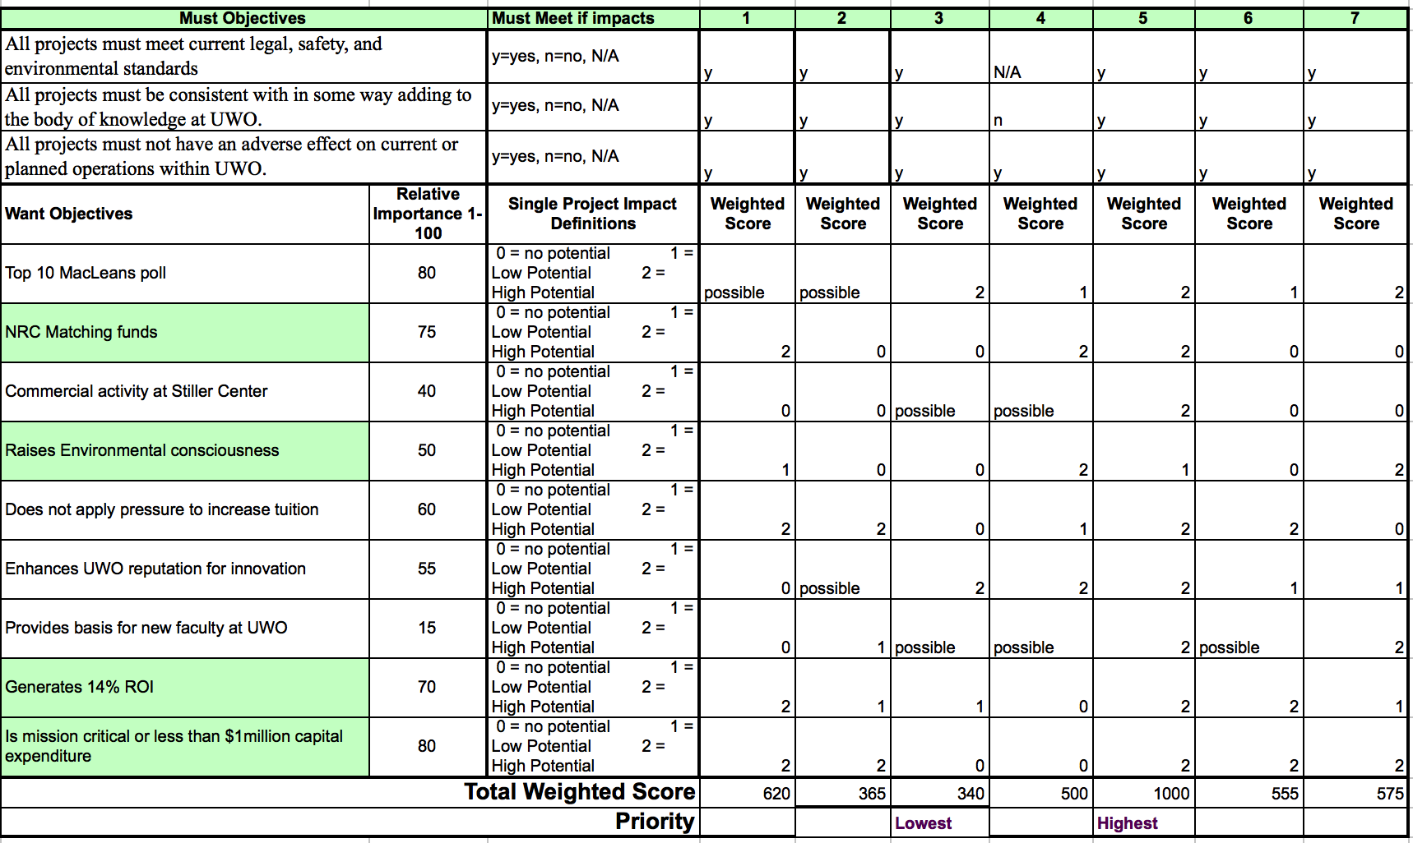

Q2.

The Time Estimate calculation will be based on the 3-points estimation which applies the Beta Distribution: tE = (tO + 4tM + tP) / 6

|  |  |  |  |  |  |
| --- | --- | --- | --- | --- | --- |
| Activity | Preceding activity | Best | Likely | Worst | Time est. |
| (TE) |
| a | - | 12 | 15 | 25 | 16.17 |
| b | a | 4 | 6 | 11 | 6.50 |
| c | - | 12 | 12 | 30 | 15.00 |
| d | b,c | 8 | 15 | 20 | 14.67 |
| e | a | 7 | 12 | 15 | 11.67 |
| f | e | 9 | 9 | 42 | 14.50 |
| g | c,d,e | 13 | 17 | 19 | 16.67 |
| h | e,f | 5 | 10 | 15 | 10.00 |
| i | c,g | 11 | 13 | 20 | 13.83 |
| j | g,h | 2 | 3 | 6 | 3.33 |
| k | j,i | 8 | 12 | 22 | 13.00 |

The critical path is the sequence of activities that represents the longest path through a project, which determines the shortest possible project duration.

The longest path is a-b-d-g-i-k.

The following diagram shows the full AON details:

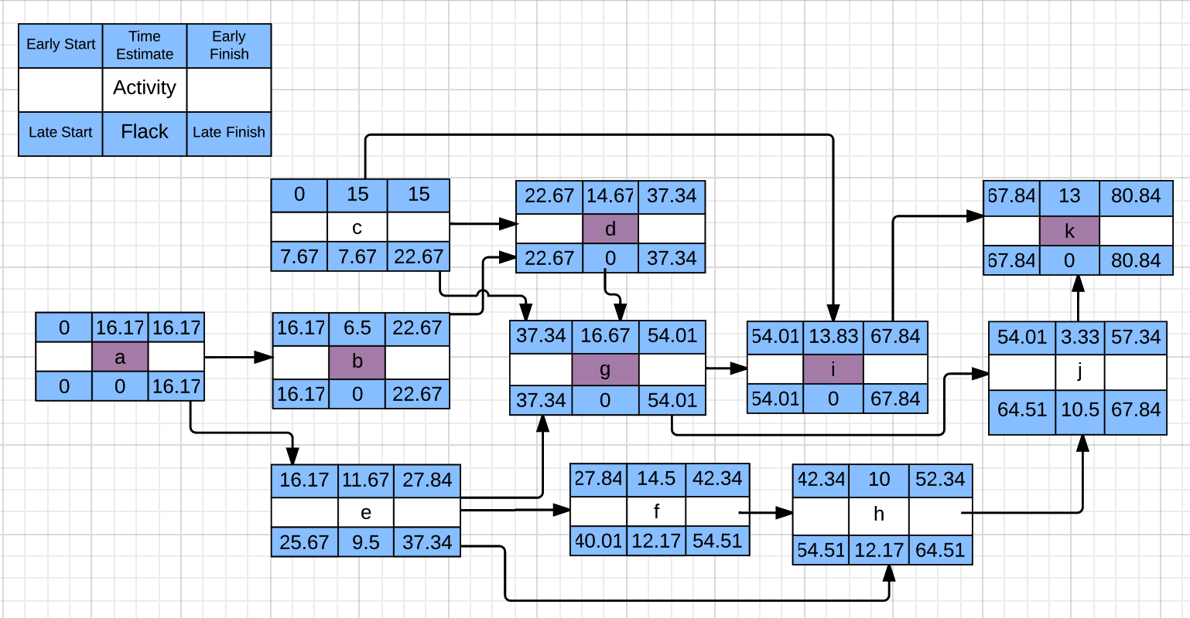

Q3.

The WBS is a hierarchical decomposition of the total scope of work to be carried out by the project team to accomplish the project objectives and create the required deliverables. The WBS organizes and defines the total scope of the project, and represents the work specified in the current approved project scope statement.

The first pig’s stew house, I would like to decompose the project by work packages: requirement & scope management, cost management, time management, resource management, and quality management etc.

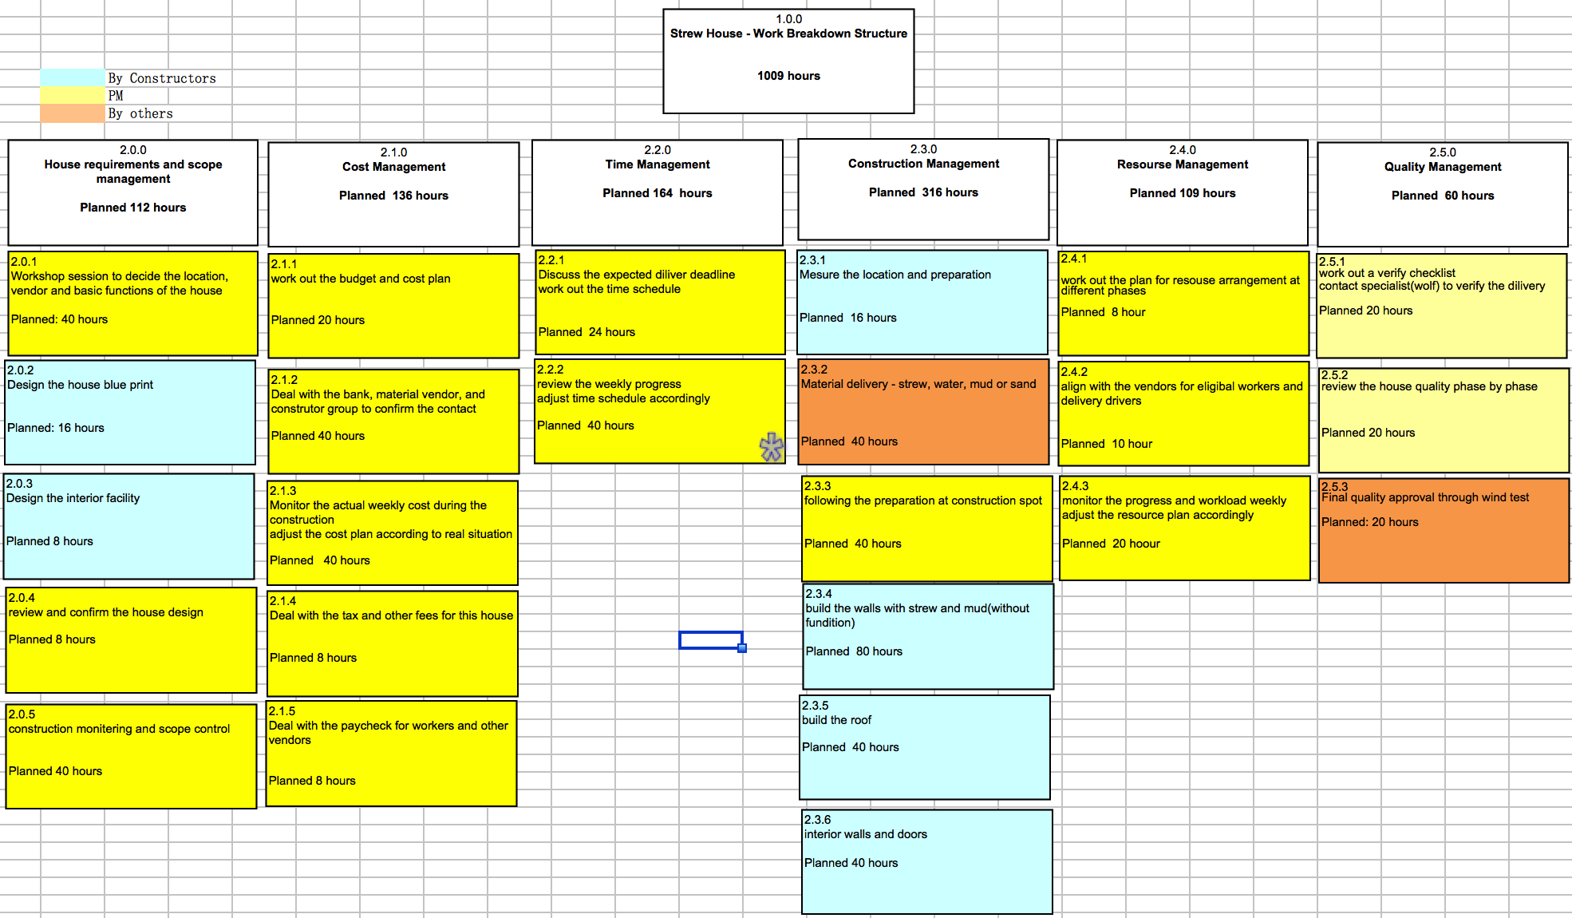

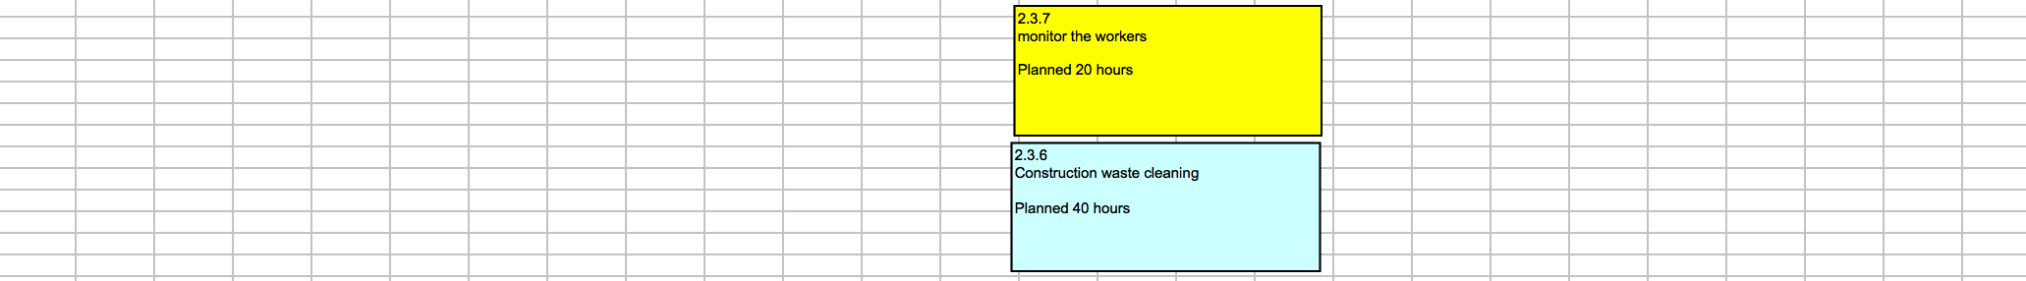

Secondly for the wood house, I would like to breakdown the work phase by phase including the planning, design, implementation, verification, and delivery.

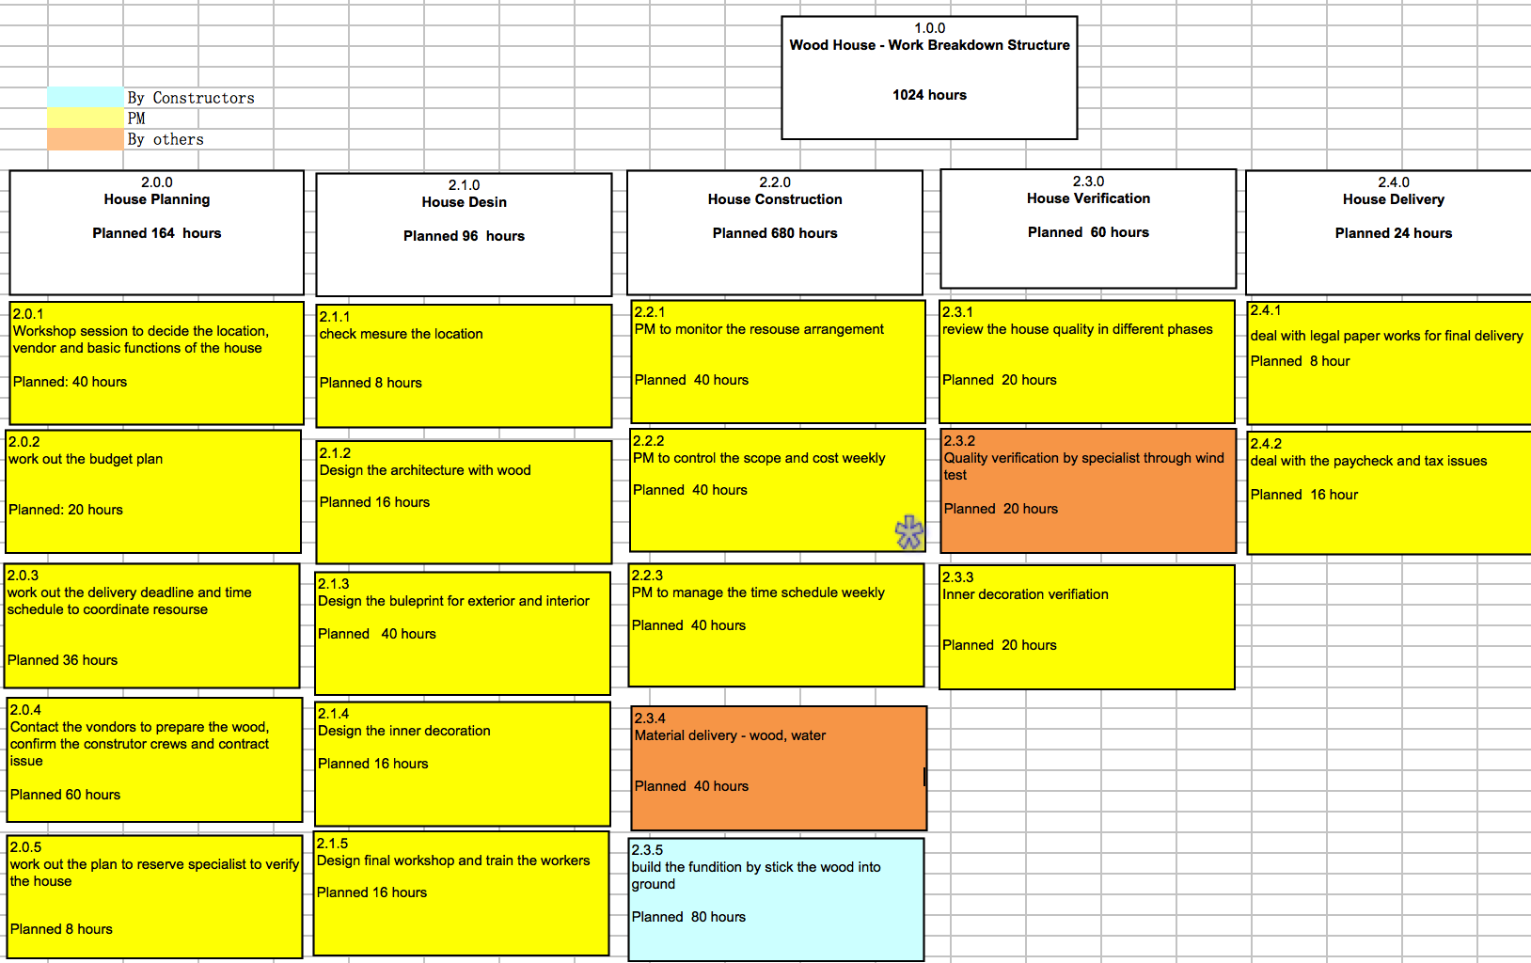



Finally the brick house will use the WBS by deliveries: Land, Materials, House architecture, decoration and interior facility.

